Graduate Student IDP Form

Name: ________________________________________________ 800#: ________________________
Degree/Program: ___________________________________________ Term/Year: _____________________
Mentor: ___________________________________________________ Date: _________________________
STEP 1: Conduct a self-assessment:
Evaluate your skills and abilities in the following areas. Consider your previous experience and skills in:

COMMUNICATION:
(1 = Needs improvement; 5 = Highly proficient) | 1 | 2 | 3 | 4 | 5 | NA
Writing for a general audience | ☐ | ☐ | ☐ | ☐ | ☐ | ☐
Writing for a discipline-specific audience | ☐ | ☐ | ☐ | ☐ | ☐ | ☐
Oral presentation for a general audience | ☐ | ☐ | ☐ | ☐ | ☐ | ☐
Oral presentation for a discipline-specific audience | ☐ | ☐ | ☐ | ☐ | ☐ | ☐
Social media communication & etiquette | ☐ | ☐ | ☐ | ☐ | ☐ | ☐
Email communication & etiquette | ☐ | ☐ | ☐ | ☐ | ☐ | ☐
Connecting with mentors | ☐ | ☐ | ☐ | ☐ | ☐ | ☐
Ability to receive constructive feedback | ☐ | ☐ | ☐ | ☐ | ☐ | ☐
Ability to give constructive feedback | ☐ | ☐ | ☐ | ☐ | ☐ | ☐
Networking inside your academic program | ☐ | ☐ | ☐ | ☐ | ☐ | ☐
Networking outside your academic program | ☐ | ☐ | ☐ | ☐ | ☐ | ☐
Other: Click or tap here to enter text. | ☐ | ☐ | ☐ | ☐ | ☐ | ☐
Other: Click or tap here to enter text. | ☐ | ☐ | ☐ | ☐ | ☐ | ☐
Comments: ____________________________________________________________________________________________________________________________________________________________________________________

TEACHING:
(1 = Needs improvement; 5 = Highly proficient) | 1 | 2 | 3 | 4 | 5 | NA
Tutoring | ☐ | ☐ | ☐ | ☐ | ☐ | ☐
Using your discipline’s teaching pedagogy | ☐ | ☐ | ☐ | ☐ | ☐ | ☐
Leading discussion section or tab | ☐ | ☐ | ☐ | ☐ | ☐ | ☐
Lecturing | ☐ | ☐ | ☐ | ☐ | ☐ | ☐
Serving as teaching assistant | ☐ | ☐ | ☐ | ☐ | ☐ | ☐
Other: Click or tap here to enter text. | ☐ | ☐ | ☐ | ☐ | ☐ | ☐
Other: Click or tap here to enter text. | ☐ | ☐ | ☐ | ☐ | ☐ | ☐
Comments: ____________________________________________________________________________________________________________________________________________________________________________________

RESEARCH SKILLS: Advanced knowledge & skills relevant to your field
(1 = Needs improvement; 5 = Highly proficient) | 1 | 2 | 3 | 4 | 5 | NA
Technical skills related to my research/creative area (e.g., analytical skills, data analysis) | ☐ | ☐ | ☐ | ☐ | ☐ | ☐
- Research design strategies | ☐ | ☐ | ☐ | ☐ | ☐ | ☐
- Record keeping practices | ☐ | ☐ | ☐ | ☐ | ☐ | ☐
- Demonstrated understanding of data ownership | ☐ | ☐ | ☐ | ☐ | ☐ | ☐
-Detailed knowledge of my research/creative area | ☐ | ☐ | ☐ | ☐ | ☐ | ☐
- Critical reading of literature in the field | ☐ | ☐ | ☐ | ☐ | ☐ | ☐
- Demonstrated knowledge of RCR | ☐ | ☐ | ☐ | ☐ | ☐ | ☐
- Understanding of how research applies to practice | ☐ | ☐ | ☐ | ☐ | ☐ | ☐
Comments: ____________________________________________________________________________________________________________________________________________________________________________________

LEADERSHIP and INTEGRITY: (Leadership; integrity; transferable skills)
(1 = Needs improvement; 5 = Highly proficient) | 1 | 2 | 3 | 4 | 5 | NA
Respecting contributions of others | ☐ | ☐ | ☐ | ☐ | ☐ | ☐
Demonstrating cultural competence | ☐ | ☐ | ☐ | ☐ | ☐ | ☐
Working with diverse groups/teams | ☐ | ☐ | ☐ | ☐ | ☐ | ☐
Taking responsibility for decision-making | ☐ | ☐ | ☐ | ☐ | ☐ | ☐
Motivating others | ☐ | ☐ | ☐ | ☐ | ☐ | ☐
Effectively managing projects & time | ☐ | ☐ | ☐ | ☐ | ☐ | ☐
Assuming leadership positions | ☐ | ☐ | ☐ | ☐ | ☐ | ☐
Participating in service opportunities | ☐ | ☐ | ☐ | ☐ | ☐ | ☐
Comments: ____________________________________________________________________________________________________________________________________________________________________________________

CAREER DEVELOPMENT:
(1 = Needs improvement; 5 = Highly proficient) | 1 | 2 | 3 | 4 | 5 | NA
CV/Résumé building | ☐ | ☐ | ☐ | ☐ | ☐ | ☐
Establishing career goals | ☐ | ☐ | ☐ | ☐ | ☐ | ☐
Awareness of career opportunities in your field | ☐ | ☐ | ☐ | ☐ | ☐ | ☐
Attending career-oriented professional development workshops | ☐ | ☐ | ☐ | ☐ | ☐ | ☐
Exploring career-focused academic certificates | ☐ | ☐ | ☐ | ☐ | ☐ | ☐
Comments: ____________________________________________________________________________________________________________________________________________________________________________________

CURRENT RESPONSIBILITIES AND CAREER GOALS
As part of the assessment process, and in preparation for creating a truly individualized IDP, ask yourself some questions related to your current responsibilities/requirements and career goals. Doing so will lead you to actions or goals to incorporate into your plan. Focus on developing skills that will lead to your success in your current role and beyond.

Short term:
What are the requirements and responsibilities you must meet during the next year? Two years?

What are the technical skills or discipline-specific knowledge that you need to develop?

What scholarly activities would you like to accomplish or work toward during the next year? Two years? (Examples: Join a professional organization, present at a conference, co-author a paper?)

Other?

Long term:
What type of work would you like to do?

What is important to you in your future career? What competencies are required for your chosen career?

How well do your current skills match the competencies required for your chosen career?

What are your short-term goals related to career exploration? (Examples: Learn how to write scientific papers; conduct informational interviews; find out where graduates in my field are working/finding careers…)

How will you develop contacts--a network--related to your career exploration goals?

Other?

Components borrowed from Florida State University Student IDP Plan

STEP 2: Write your own Individual Development Plan Date:___________________
This should reflect your plans as they stand currently. This is your “action plan.”

COMMUNICATION GOALS
Objectives/ skills to learn | Approaches & strategies | Timeframe | Oucomes

TEACHING GOALS
Objectives/ skills to learn | Approaches & strategies | Timeframe | Oucomes

RESEARCH GOALS
Objectives/ skills to learn | Approaches & strategies | Timeframe | Oucomes

LEADERSHIP GOALS
Objectives/ skills to learn | Approaches & strategies | Timeframe | Oucomes

CAREER DEVELOPMENT GOALS
Objective | Approaches & strategies | Timeframe | Oucomes

OTHER GOALS
Objectives/ skills to learn | Approaches & strategies | Timeframe | Oucomes

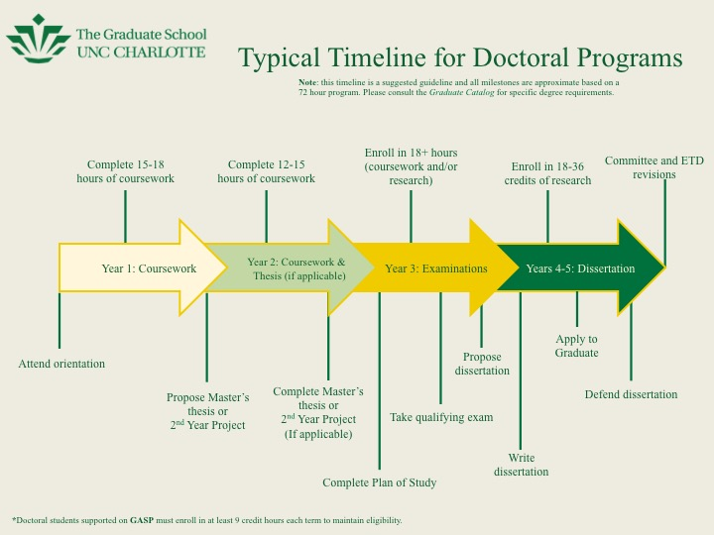
Annual Review Date: _____________________
Annual Review: This section will help remind you and your advisor about your accomplishments over the past year as well as your future goals. Please list and explain your accomplishments in the below, areas as this will be used to evaluate your progress and help identify areas you need to concentrate on going forward. If you have nothing to report in an area, please note that with N/A
Research: List any current research projects. Include your specific role on the project, where the project stands, and expected outcomes of the project. Grant and fellowship applications should be noted here as well.

Academic Performance: List the courses taken this year and grades received.

Teaching: List any courses you have taught, workshops conducted, teaching assistant activities, or guest lectures. Describe the course (course number and title, class size, etc.) or workshop and your specific role. Describe any workshops or seminars you attended on teaching or any other activities you did in an effort to develop your teaching (e.g., peer observation of your teaching).

Applied Work: List any applied experiences you have participated in. Include your specific role, a progress report on the project, and expected outcomes.

Assistantships: Explain any assistantships you held and what activities you did.

Professional Development/Service to the Profession (not the program): Explain any professional development activities you engaged in over the last year. This may include attending conferences, seminars, or workshops; joining professional organizations, attending meetings, or serving as an officer or on a committee; submitting papers to and presenting at conferences; submitting papers to journals.

Program Progress: Given your year in the program, explain how well you are making progress in the program. Please be specific (e.g., finished qualifying exam).

Service to the Program/Community. This is where you indicate the service you have done to support the program and community (e.g. serving as president; volunteer activities).

Goal Accomplishment: Did you accomplish all that you agreed on doing with your mentor, under the Action Plan during your initial meeting? If not, what parts of the plan did you not accomplish and why? Describe/list any unusual or unanticipated challenges experienced.
Mentor Comments:
________________________________________________________________________________________________________________________________________________________________________________________________________________________________________________________________________________________________________________________________________________________________________________________________________________________________________________________________________________________________________________________________________________________________________________________________________________________________________________________________________________________________________

Recommended Next Steps for the coming year:

Research:

_____________________________________________________________________________________

Teaching:

_____________________________________________________________________________________

Professional Development:

_____________________________________________________________________________________

Academic Progress:

_____________________________________________________________________________________

___________________________________ _________________________________
Mentee Mentor

